**DIGITAL MEDIA MARKETING USING NEURAL NETWORK SYSTEM**

**Mrs.K. Shunmuga Priya, Assistant Professor, Department of Computer Science and Applications,**

**Jeppiaar College of Arts and Science, Chennai.**

**D.Bhuvaneshwar**, **Department of Computer Science and Applications,**

**Jeppiaar College of Arts and Science, Chennai.**

**B. Pavithra**, **Department of Computer Science and Applications,**

**Jeppiaar College of Arts and Science, Chennai.**

**ABSTRACT:**

For the past few years, E-Commerce is the most popular platform that we using in our day-to-day life. The definition of ecommerce business can also include tactics like affiliate marketing. Advertising the products is the major challenge in E-Commerce. In E-Commerce, also called online marketing, is the promotion of brands with potential customers using the internet and other forms of digital communications. Basically, Advertising the products in this Digital media marketing platform is the most challenging task. Every people have their own need depends on their requirements. In this project, Using “Market Basket Algorithm” in a particular area by Neural network system using regression, we can handle and advertise the products to the preferred specific people through online platforms like Facebook, Instagram etc…

Neural networks are designed to work just like the human brain does, And market basket algorithm is used to increase sales by better understanding customer purchase patterns.

**Keywords:** Market Basket algorithm, Neural network system.

**INTRODUCTION:**

Digital marketing is the use of digital technologies and platforms to promote products and services, as well as to connect with potential customers. It is an incredibly versatile and powerful tool that can be used in various ways to reach people worldwide. Digital marketing utilizes multiple digital technologies to deliver promotional messages, such as mobile phones, computers, and other digital media and platforms. It can be used for B2B (Business to Business) and B2C (Business to Consumer) marketing, depending on the goal and objectives of the campaign. Digital marketing offers unique advantages such as greater reach, improved targeting, personalized messaging, and better ROI (Return on Investment). It also allows businesses to stay up-to-date with marketing trends and technologies. With the right strategies and tactics, companies can leverage digital marketing to increase their visibility and reach a larger audience. It has many advantages, but has some disadvantages too. Some disadvantages are security and privacy issues, trust and credibility, advertising, time consumption and accessibility etc. this paper mainly focus on the advertising part. because, various methods were undertaken to advertise the products like bit notice, wall paintings and so on. But it reaches on to a very few people.so we are going to advertise through social media.

**REVIEW OF LITERATURE:**

**Arjun Mittal** in his study on E-Commerce: It’s Impact on consumer behaviour analysed that how the E-commerce companies make marketing strategies according the research data and analysing result. This paper mainly focuses on those factors that affect the consumer’s online shopping behaviours.

**Hasan Beyari** in his study on recent E-Commerce trends and learnings for E-Commerce system development from a quality perspective showed that the system will need to exhibit the following characteristics: gain the trust and confidence of customers by aligning the system with the best practices in online transactions; use suitable digital technologies to facilitate the display of products, information regarding safety, e-ordering, and payment; and ensure there is sufficient supply of the products offered.

**Kumar Anuj*-Fahad Fayaz**-Ms Namita Kapoor\*\*\*** on their study on Impact of E-Commerce in Indian Economy analysed that E- Commerce is great platform not only to develop infrastructure but also increase employment rates in India and thus overall impact in increasing economic and social growth in Indian economy.

**Dr.V. Josephine Lourdes De Rose** on her study on E-Commerce shows that analyse the various preference factors which affect their purchase decision through online mode.

**Saani Soloman*-Majji Lokesh**-Jayaprakash Lamoriya\*\*\***on their study on E-Commerce platform on consumer’s mindset reveal that internet customer trust and perceived risk have significant influences on their purchasing decisions. The key issues include consumer trust, privacy concerns, and security problems.

**EXISTING SYSTEMS:**

Digital media marketing is the people’s best platform where they buy their preferred goods and products. Even though the products are good there is great issues still available in advertising those things. For the past few years or the starting time of these platforms, they used to give bit notice, painting on the walls, Issue a press release, Give out free samples, Issue a press release, Give out free samples, Consumer-generated advertising etc... This are the existing systems in this project. But still we having lots of advertising and time management issues.

Digital advertising (also known as online advertising) is a form of marketing used by companies to promote their brand, product, or service through digital channels.It consists of actions in web browsers, social media pages, blogs, apps, or any other form of contact through the Internet. Digital advertising is a process of migration and adaptation of companies to the movement that society as a whole has undergone.

The 4 best digital advertising examples are Search engine marketing, display advertising, social media ads and email marketing.

In this project we consider social media ads as our existing system. Social media platforms allow users to spend time with more relevant content than traditional advertisements; Making social ads more valuable because they are more likely to be seen by the people that matter most for a product or service. Social Media ads are being seen as one of the most effective tools in advertising.  social media marketing has a wide range of benefits for businesses, including improved brand recognition, targeted advertising, cost-effectiveness, and in-the-moment engagement. However, it also has its fair share of disadvantages, like time restrictions, unfavorable comments, and reliance on platform algorithms.

Businesses must carefully balance the advantages and disadvantages before developing a social media marketing strategy that works for their unique objectives and target market. In the digital age, social media marketing can without a doubt be a game-changer for driving business growth and creating deep connections with customers. So in this project we are going to modify the social media advertising by adding our techniques.

**PROPOSED SYSTEM:**

**NEURAL NETWORKS:**

A Neural Network is a machine learning program, or model, that makes decisions in a manner similar to the human brain, by using processes that mimic the way biological neurons work together to identify phenomena, weigh options and arrive at conclusions.

Think of each individual node as its own linear regression model, composed of input data, weights, a bias (or threshold), and an output. The formula would look something like this:

∑wixi + bias = w1x1 + w2x2 + w3x3 + bias

output = f(x) = 1 if ∑w1x1 + b>= 0; 0 if ∑w1x1 + b < 0

Once an input layer is determined, weights are assigned. These weights help determine the importance of any given variable, with larger ones contributing more significantly to the output compared to other inputs. All inputs are then multiplied by their respective weights and then summed. Afterward, the output is passed through an activation function, which determines the output. If that output exceeds a given threshold, it “fires” (or activates) the node, passing data to the next layer in the network. This results in the output of one node becoming in the input of the next node. This process of passing data from one layer to the next layer defines this neural network as a feedforward network.

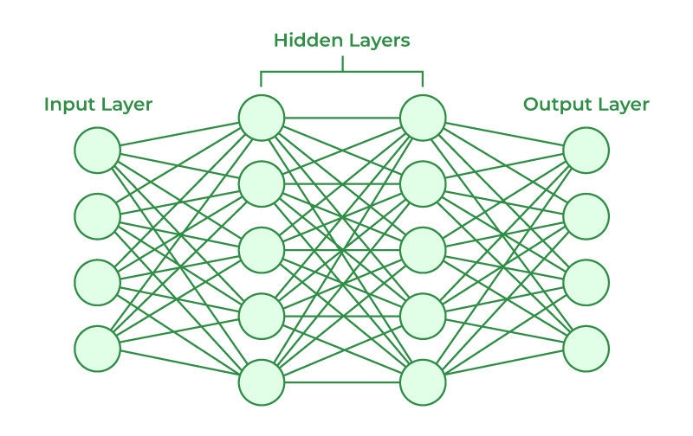

NEURAL NETWORK SYSTEM

**MARKET BASKET ANALYSIS:**

Market basket analysis is a [data mining](https://searchsqlserver.techtarget.com/definition/data-mining) technique used by retailers to increase sales by better understanding customer purchasing patterns. It involves analysing large data sets, such as purchase history, to reveal product groupings, as well as products that are likely to be purchased together.

Implementation of market basket analysis requires a background in statistics and [data science](https://www.techtarget.com/searchenterpriseai/definition/data-science), as well as some algorithmic computer programming skills. For those without the needed technical skills, commercial, off-the-shelf tools exist.

Market basket analysis can increase sales and [customer satisfaction](https://www.techtarget.com/whatis/definition/customer-satisfaction-CSAT). Using data to determine that products are often purchased together, retailers can optimize product placement, offer special deals and create new product bundles to encourage further sales of these combinations.

Market basket analysis utilizes association rule {IF} - > {THEN} to predict the probability of certain products being purchased together. They count the item frequency occurring together and seek to find associations that occur more than expected.

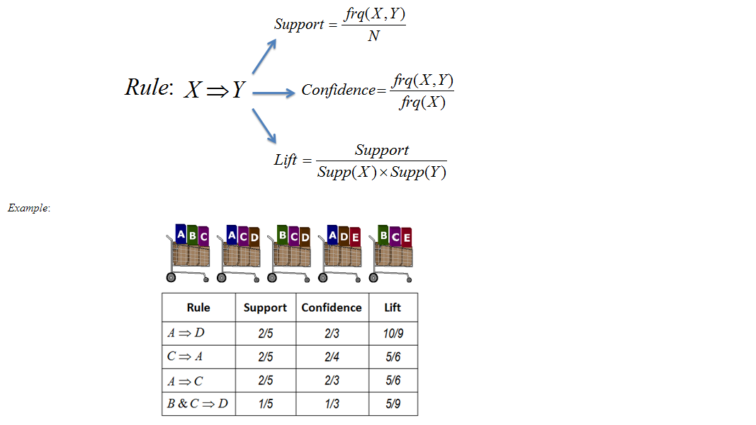

In order to find the answer to this question, we need to extract “age” from the preferred people.

retail$age <- as.factor(retail$age)  
a <- hms(as.character(retail$age))  
retail$age = people(a)retail %>%   
 ggplot(aes(x=age)) +   
 geom_histogram(stat="count",fill="indianred")



AGE

PEOPLE

In this whole project we mentioned about market basket algorithm not the market basket analysis.Because the analysis is taken and used as an algorithm here.

By using Market Basket algorithm, we can advertise the related products and by using Neural networks we can advertise through online to the specific area and people to their preferred goods. Thus, by using “Market Basket Algorithm” in a particular area by Neural network system using regression, we can handle and advertise the products to the preferred specific people through online platforms**.**

**CONCLUSION:**

The current state of E-Commerce in India is the topic of this research. Here we showed that we can advertise the products by combining those two fixtures very easily.In future, we can add some more analysis and algorithms to get great results in real time world.

Thus, we concludes that in Digital Media Marketing using Neural Networks we can advertise the products very easily.

**REFERENCE:**

***[1] Black, G.S. (2005) is eBay for everyone? An Assessment of Consumer Demographics, SAM Advanced Management Journal, winter, Vol. 70 Issue***

***[2] BMRB International (2004) Hadley House, 79-81 Uxbridge Road, Ealing, London, W5 5SU. Internet Monitor Data.***

***[3] Brucks, M. (1985) The effect of product class knowledge on information search behavior. Journal of Consumer Research, Vol. 2, pp.1–16.***

***[4] Buyer decision processes, 2006, Wikipedia is a registered trademark of the Wikimedia Foundation, Inc. Available at: http://en.wikipedia.org/wiki/Buyer_decision_processes***

***[5] Cassell J. and Bickmore T. (2000) External manifestations of trustworthiness in the interface. Communications of the ACM December: 50-56.***

***[6] Fayu Zheng. 2006. Internet shopping and its impact on consumer behavior. University of Nottingham***

***[7] Cox D and Rich Su (1964) Perceived risk and consumer decision making – the case of telephone survey. J Mark Res; 1 (November): 32-9.***

***[8] BCG & IAMAI. (2015) India @ Digital Bharat. Creating a $200 Billion Internet Economy. Mumbai: The Boston Consulting Group.***

***[9] BCG. (2012). The Connected World.The Internet Economy in the G20. the $ 4.2 Trillion Growth Opportunity. Boston: The Boston Consulting Group.***

***[10] Bilbao-Osorio, B., Dutta, S., & Lanvin, B. (2013) The Global Information Technology Report 2013. Geneva: World Economic Forum***